**Malik Abdul Ghafoor Rafay**

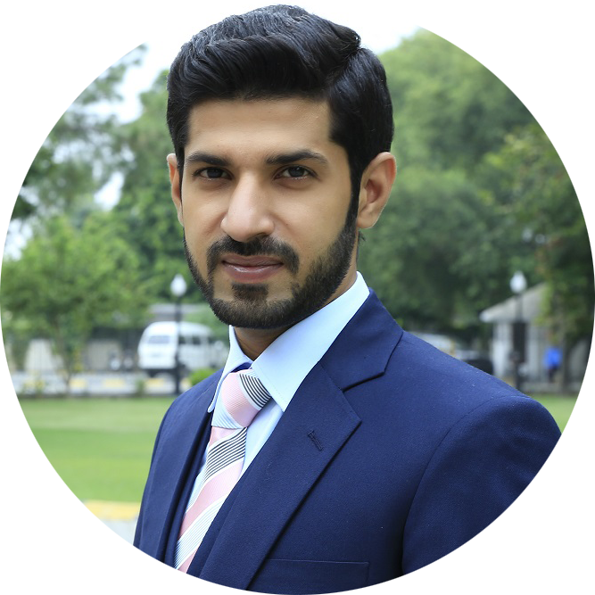

**Nadra Abad Street # 01,**

**Badian Road Lahore Cantt, Lahore.**

[**magrafay@gmail.com**](mailto:magrafay@gmail.com)

**+92317-4090064**

|  |
| --- |
| **Seeking Job in IT Profession** |

Seeking jobas Front-end Developer, enabling growth and learning opportunities in a creative, fast-paced, forward-thinking organization.

|  |  |  |
| --- | --- | --- |
|  | **Programming and tools Skills** |  |

|  |  |  |  |  |  |  |  |  |
| --- | --- | --- | --- | --- | --- | --- | --- | --- |
| • **xHTML & HTML:** Proficient  • **Bootstrap 3 & 4:** Proficient  • **CSS & CSS3:** Proficient  • **jQuery & 3rd Part:** Proficient  • **Primefaces / Bootfaces:** Proficient  • **Alloy UI:** Proficient  • **Freemarker / Velocity:** Proficient | | • **Visual Studio Code:** Proficient  • **R Studio:** Proficient  • **Liferay 6:** Proficient  • **Adobe Photoshop:** Proficient  • **Adobe Illustrator:** Proficient  • **Unity3d:** Familiar  • **MS Office Suit 2013:** Proficient | | | | • **Project Documentation:** Familiar  • **Manual Testing:** Familiar  • **WordPress:** Familiar  • **Page Speed:** Proficient  • **SEO Techniques:** Proficient | | |
|  | | | **Experience** | |  | | |
|  | | |  | |  | | |
| **INFOGISTIC, Lahore, PK** | | | **Front-end Developer,** **Nov-2016 to Present** | | |

* Working as front-end developer, creating web applications UI design to HTML5, xHTML, CSS, CSS3, Freemarker, Velocity and jQuery.
* Ensure the technical feasibility of UI Designs.
* Working on various project using **Liferay** with **Primefaces** & **Bootfaces** framework.
* Creating navigations in.
* Creating Environment in eclipse.
* Optimize application for maximum speed and scalability.
* Collaborate with other team members and stakeholders.

|  |  |
| --- | --- |
| **ITBEAM, Lahore, PK** | **Front-end Developer & Designer,** **Aug-2016 to Oct-2017** |

* Working as front-end developer converted PSD, Firework and InDesign website designs to HTML5, CSS and jQuery.
* Ensure the technical feasibility of UI Designs for web and mobile apps that validated deliverables meet functional and design specifications and requirements.
* Working on various project using Twitter Bootstrap framework.
* Working on CMS: WordPress: (Theme Installation & Customization).

|  |  |
| --- | --- |
| **KHASOL, Lahore, PK** | **QA & Front-end Developer,** **Dec-2015 to Aug-2016** |

* Worked as Graphics Designer using different tool i.e. Photoshop, Illustrator for designing.
* Worked on various project using Bootstrap framework.
* Develop new user-facing features.
* Developed websites in i.e. HTML/ CSS & jQuery.
* Also perform quality assurance testing across multiple browsers, platforms, and devices, including smartphones and tablets.

|  |  |
| --- | --- |
| **VITAL AIMS, Lahore, PK** | **Web-Designer,** **May-2015 to Nov-2015** |

* Used CorelDraw, Adobe Photoshop designed images, Brochure, logos and apps.
* Ensure the technical feasibility of UI Designs for web and mobile apps that validated deliverables meet functional and design specifications and requirements.

|  |  |  |  |  |
| --- | --- | --- | --- | --- |
|  | **Education** |  | | |
| **MCS, Virtual University,** Lahore, PK  **B.Com IT, University of South Asia,** Lahore, PK  **FSC. (PRE ENGG.), Leadership College (UMT**)**,** Lahore, PK  **Matriculation, Rana Model High School**, Lahore, PK | | | Ongoing  Complete 2011  Complete 2007  Complete 2005 |

|  |  |  |
| --- | --- | --- |
|  | **Personal Interest** |  |

* R&D in web development and designing.
* Exploring new web designing tool and working on them learning new skills.

|  |  |  |
| --- | --- | --- |
|  | **Reference available on request** |  |